UWFNet: A Fusion Based Method for Underwater Image Enhancement

Raghav Arora(22BCE1027) [raghav.arora2022@vitstudent.ac.in](mailto:raghav.arora2022@vitstudent.ac.in) *SCOPE, VIT Chennai*

Tejal Sharma(22BCE1021) [tejal.sharma2022@vitstudent.ac.in](mailto:tejal.sharma2022@vitstudent.ac.in) *SCOPE, VIT Chennai*

***Abstract*—Underwater photographs are bound to be affected by color cast, contrast loss, and reduced visibility. In this paper, we propose a pipeline that can remarkably enhance underwater images to enhance visualization of an object in the foreground without compromising on natural background characteristics. The pipeline is made up of several steps, such as adaptive color refining to make image tones uniform, image decomposition into a base and detail layer to allow more control over enhance- ment, contrast enhancement to enhance foreground details, and sophisticated methods in light estimation for atmosphere and transmission map optimization to reduce the effect of water haze and enhance image clarity. Saliency-guided contrast enhancement and edge-aware filtering are incorporated within our method to adaptively enhance the foreground without over-enabling the background. Experimental evidence supporting the efficacy of the proposed method in restoring underwater images without compromising their intrinsic beauty is provided by observing good quality improvements in both qualitative and quantitative analysis. The potential of the approach for use in oceanography, environmental research, and underwater exploration is further illustrated by the findings.**

***Index Terms*—Underwater Image Enhancement, Contrast Enhancement,Foreground-Background Decomposition, Atmo- spheric Light Estimation, Dehazing, White Balancing**

1. Introduction

Underwater image processing technology is particularly important for numerous applications including underwater archaeology, sea surveys, oceanic biology, and deep ocean engineering. Imaging underwater is difficult because water medium properties make light to be absorbed, scattered, and color aberrant. The complex multi-physics factors in seawater significantly blur image quality, reduce visibility, and obscure significant scene features and thus limit successful underwater visual monitoring and information capture.

For solving such problems, researchers have investi- gated different classes of enhancement methods: restoration- based methods, traditional enhancement algorithms, and deep learning-based methods. Methods based on restoration tend to use physical models and priors but involve intricate parameter estimation and are computationally expensive. Contrariwise, image enhancement processes are usually lightweight in terms of execution but may create color aberrations or add noise due to their failure to factor in models for underwater image formation. Deep learning techniques also held high expec- tations but suffer the hindrance that only paired massive amounts of training datasets make use practicable in realistic

contexts because gaining such training material underwater comes automatically with intrinsic hurdles.

In this paper, we introduce a modular enhancement pipeline to enhance the visual quality of underwater degraded images using a combination of traditional image processing methods and new visual clues. Our approach consists of multiple key steps: white balance adjustment, foreground–background separation, contrast enhancement based on percentile statistics, atmospheric light estimation, transmission map estimation, and multi-stage dehazing and entropy based fusion. These phases operate in conjunction to recover image contrast, eliminate color casts, and uncover hidden details.

We highlight our core contributions as follows:

* We propose a white balancing approach that remaps the CIELab’s chromaticity channels by assessing the statistical imbalancing among the a and b components.
* We incorporate an intuitive foreground-background sepa- ration mechanism based on intensity separation metrics to localize and amplify subject features and separate haze- dominant background areas.
* We design a percentile-based contrast enhancement methodology, normalizing illumination within RGB chan- nels based on statistical thresholds to ensure local contrast and suppress outlier values.
* We incorporate a region-aware statistical scoring and minimum distance heuristics-based atmospheric light es- timation scheme, followed by a block-based transmission map estimator, allowing for robust dehazing of underwa- ter scenes with turbidity.
* We propose an entropy-based image fusion technique that effectively combines foreground and background information, selecting the most informative regions from both to produce a single image with enhanced entropy and improved visual quality.

This multi-step method is modular, interpretable, and flexible in enhancement and thus applicable to a broad spectrum of underwater image conditions, from bluish to greenish colors, and from low-contrast to highly turbid conditions.

1. RELATED WORK

Currently, scientists have proposed many ways to enhance underwater visual perception, which can be divided into three broad categories: image restoration, image enhancement, and deep learning. All three types deal with various kinds of

underwater image degradation, including color aberration, low contrast, and scattering and absorption caused by water. Phys- ical modeling of the underwater scene is the basis for image restoration techniques, visual enhancement techniques try to enhance quality based on statistical or heuristic modifications, and data-driven learning based adaptation for correcting and enhancing image features is the case with deep learning techniques. The summary of these approaches is as follows.

1. *Image Restoration Methods*

Image restoration techniques try to restore clear underwater images by representing and inverting degradation processes characteristic of underwater conditions. They usually depend on physical models, prior information, and variational meth- ods. Chiang and Chen [5] introduced an algorithm that corrects wavelength attenuation and dehazes the image to remove color distortion and low contrast in underwater images. Li et al. [4] presented a medium transmission-guided multi- color space embedding method, combining physical modeling with deep learning to improve underwater images efficiently. Ancuti et al. [2] proposed a color balancing and merging technique that blends several inputs for enhancing the visual quality. Iqbal et al. [3] introduced an integrated color model technique, which aims to enhance underwater images through the alteration of color channels using statistical calculation. Zhang et al. [1] proposed a principal component fusion method that disentangles the background and foreground components in order to improve underwater images. It has highlighted the need for treating various image regions in isolation to achieve effective improvement.

1. *Traditional Enhancement Techniques*

Traditional enhancement techniques aim to enhance im- age quality using methods such as color correction, contrast control, and histogram equalization without the use of so- phisticated models. Ancuti et al. [2] used color balance and fusion techniques to improve underwater images, proving the efficacy of fusing different enhancement methods. Iqbal et al. [3] used an integrated color model to manipulate color channels, enhancing the aesthetic value of underwater photos. Zhang et al. [1] used principal component analysis to inte- grate foreground and background features to increase image definition and detail. The techniques bring to the forefront the potential of traditional methods to deal with underwater image degradation.

1. *Deep Learning-Based Methods*

Deep learning methods have become the center of attention for underwater image enhancement because they can learn mappings from degraded to enhanced images that are complex in nature. Li et al. [4] presented a deep learning framework with medium transmission-guided multi-color space embed- ding that balances physical models and neural networks. Qi et al. [6] presented a co-enhancement method based on corre- lation feature matching and joint learning and demonstrated enhanced performance for underwater image enhancement

tasks. Zhang et al. [7] designed a locally adaptive contrast enhancement and minimal color loss technique, using deep learning to solve color distortion and low contrast. Zhou et al. [8] proposed a feature prior-based restoration, estimating background light and optimizing transmission maps using deep networks. Qi et al. [9] presented SGUIE-Net, a se- mantic attention-guided network with multi-scale perception, which improves underwater images by emphasizing semantic areas. Cong et al. [10] presented PUGAN, a GAN-based method guided by physical models, using dual discriminators to effectively improve underwater images. Quan et al. [12] proposed an asymmetric multiscale invertible network that extracted multiscale features to improve underwater image quality. Li et al. [13] offered a color correction and guide image filtering technique by combining deep learning with conventional filtering methods. Wang et al. [14] proposed UIERL, a network of internal-external representation learning, upgrading underwater images based on learning both internal and external representations. Jiang et al. [15] proposed a non- paired deep enhancement approach, with perception-driving based on using unpaired data to train. Li et al. [16] proposed the EUICN, an efficient network for compressing and improv- ing underwater images simultaneously.

1. METHODOLOGY

In underwater imaging, visual degradation occurs as a result of wavelength-dependent light attenuation and for- ward/backward scattering effects, which produce color casts, low contrast, and haze. To mitigate these issues, we introduce a structured image enhancement pipeline that takes advantage of color correction, component-wise processing, and entropy- guided fusion. The approach involves six major stages: (i) white balancing, (ii) image decomposition, (iii) foreground enhancement, (iv) background dehazing, (v) entropy-based fusion, and (vi) color refinement. The whole process of im- provement is shown in Fig. 1.

*A. Motivation*

Most of the currently used enhancement methods treat the entire image as a whole, independent of the spatial hetero- geneity intrinsic in underwater views. Underwater images, nevertheless, typically consist of object-oriented foreground areas and distant, extremely degraded background ones. Uni- form improvement methods have the tendency to either over- emphasize unscrambled regions or fail to sufficiently recover remote details. To overcome these constraints, we suggest a layered enhancement approach that initially separates the image into foreground and background parts according to luminance features. The foreground is enhanced by contrast stretching to restore object textures, whereas the background is restored by a dehazing process based on the atmospheric scattering model. These enhanced parts are then adaptively combined using entropy as a statistical measure of informa- tion content. The reason for this framework is to provide localized improvement that is content-aware and adaptive to

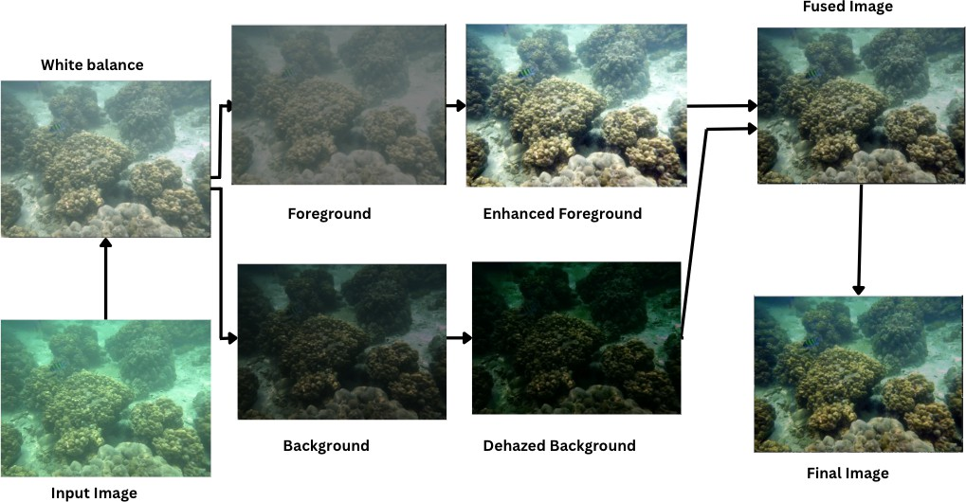

Fig. 1: Flowchart of the Proposed Methodology

spatial degradations, thereby yielding perceptually balanced and visually acceptable results.

*B. White Balance Correction*

Underwater images usually have an overwhelming blue or green color because the red light is attenuated so rapidly in water. To counter this effect, the input image is converted to the LAB color space, in which luminance (L) is separated from the chromaticity components (a and b). The mean of the a and b channels is determined as the prevailing color cast. A correction term is then calculated as:

*α*=0.5, which provides a fair split-up between the foreground layer and background layer. By employing the map *k*(*x*), the foreground portion *F* (*x*) and the background portion *B*(*x*) are given as:

*F* (*x*) = (1 − *k*(*x*)) · *I*(*x*) (5)

*B*(*x*) = *k*(*x*) · *I*(*x*) (6)

*D. Foreground Contrast Enhancement*

The foreground of underwater images is generally not suffi-

*a*′ = *a* −

avg*a* − 128 · *L* · *α*

255

(1)

ciently contrasting because light is scattered, thus diminishing the contrast of details. To make the foreground contrast more enhanced, we perform percentile-based contrast stretching on

*b*′ = *b* − avg*b* − 128 · *L* · *α* (2)

255

*α* = 1*.*1 (3)

*C. Image Decomposition*

To process foreground structures and haze in the back- ground separately, we factor the white-balanced image into two semantically significant terms: the foreground, which

each of the color channels (red, green, and blue) independently. This process is selected since it is quite good at enhancing contrast without causing excessive noise or artifacts.

Contrast stretching is done by clipping extreme values in all channels according to the 0.1st and 99.5th percentiles of pixel intensities. They suppress the impact of extreme light or dark values (outliers), which might distort the contrast enhancement. The given transformation is applied:

clip(*I, P*0*.*1*, P*99*.*5) − *P*0*.*1

tends to hold large objects and structural information, and the background, which tends to be more deteriorated by haze and

*I*′ =

*P*99*.*5 − *P*0*.*1

(7)

low-frequency lighting. Such a factorization is done within the normalized intensity space to realize uniformity irrespective of image scale variations.Specifically, the input image I(x) is first scaled to the range [0,1] [0,1], and a separation coefficient map *k*(*x*) is computed at each pixel location as follows:

This formula normalizes the pixel values to [0, 1] range

following clipping, increasing the contrast of midtones and visibility of object boundaries and edges. Separately trans- forming each channel, we enhance the local contrast of the image, making the foreground structures well visible.

*k*(*x*) = *α* · *I*(*x*)

max(*I*)

(4)

*E. Background Dehazing*

The background of underwater scenes in underwater images

where *α* ∈ [0*,* 1] is a tunable parameter governing the strength of separation, and max(I) denotes the maximum intensity value in the normalized image. In our implementation, we fix

is usually filled with haze, caused by light scattering during propagation in water. We remove this with a multi-step de- hazing algorithm based on the atmospheric scattering model.

We want to retrieve the original scene by estimating haze and eliminating it.

1. *Atmospheric Light Estimation*

The initial operation when dehazing is to make an es- timate of the atmospheric light (*A*), i.e., the color of the light dispersed in the scene. We divide the image into four quadrants and compute a score function in terms of the mean and standard deviation of each color channel. The score is expressed by:

*F. Entropy-Based Fusion*

We do so individually enhance the foreground and back- ground, and finally fuse them together using an entropy- based fusion algorithm. The main concept behind entropy- based fusion is the fusion of foreground and background to provide maximum content in the resulting fused image. Entropy measures information according to the quantity of detail and texture present in an image. Entropy of a sub-image (either foreground or background) is given as:

255

Σ

score =

Σ

*c*∈{*R,G,B*}

(*µc* − *σc*) (8)

*E* = − *pi* log2(*pi* + *δ*) (12)

*i*=0

The most highly valued quadrant generally holds the brightest area of the image, which in turn is likely to be the atmospheric light. We consider the pixel closest to pure white among this quadrant to be the atmospheric light A.

1. *Transmission Map Estimation*

where *pi* is the normalized intensity histogram of pixels, and *δ* is a small number for purpose of numerical stability. Lastly, the fusion image calculated in this step may be resolved with a weighted summation of foreground and background features according to the corresponding entropies as

*EF* · *F* + *EB* · *B*

The second one is to estimate the transmission map *t*(*x*),

*I*fused =

*EF* + *EB*

(13)

which is the un-scattered light reaching the camera at each pixel. We get a rough transmission map by computing local minima of non-overlapping patches (15x15 pixels). Transmis- sion is computed as:

*t*(*x*) = 1 − min  *I*(*x*) (9)

patch max(*I*)

This equation monitors the amount of light that reaches every pixel, darker pixels equating to greater numbers of haze. This approximation is the foundation of the transmission map.

1. *Transmission Map Refinement*

The coarse transmission map is typically noisy and must be regularized. We regularize the transmission map by applying a guided filter, using the background image as the guide map. The filter regularizes the transmission map without destroying the crucial edges so that more precise light transmission estimation becomes possible. The guided filter estimates the smoothed transmission map by linearly transforming the equa- tion.

*q*(*x*) = *a*(*x*) · *I*(*x*) + *b*(*x*) (10)

where *a*(*x*) and *b*(*x*) are coefficients derived from the local image statistics. This process makes the edges stronger in the transmission map and improves the accuracy of haze removal as well.

1. *Radiance Recovery*

Based on the enhanced transmission map, we can recover the dehazed background image *J*(*x*) as follows:

*I*(*x*) − *A* · (1 − *t*(*x*))

where *EF* and *EB* are the foreground and background en- tropies, respectively. By doing so, more informative regions shall have a greater influence in the resulting image.

*G. Final Color Enhancement*

In order to improve the visual perceptibility of the image we perform a final color enhancement step.This step involves boosting the saturation,contrast and brightness of the resulting image to obtain a image that is more aesthetically pleasing to the human eye.

We convert the image from the RGB color space to the HSV(Hue,Saturation and Value) color space where saturation and brightness can be adjusted more conveniently.In this space, the saturation is increased to make the colors more vivid and the brightness is adjusted to the improve the overall brightness of the image. After these adjustments the image is converted back to the RGB color space.Mathematically this enhancement can be expressed as:

*S*′ = *α.S* (14)

*V* ′ = *β.V* (15)

where S and V are the original saturation and value channels, and *α >* 1, *β >* 1 are gain factors used to enhance saturation and brightness, respectively.*α* and *β* are carefully chosen to prevent oversaturation and brightness clipping.This process en- sures that the resulting output image has a natural appearance while emphasizing key details, particularly in previously dull or flat areas.

1. Experiments and Discussions

In this section, we present a comprehensive qualitative and

*J*(*x*) =

*t*(*x*) + *ϵ*

(11)

quantitative evaluation of our suggested UWFNet approach on three benchmark test datasets.

where *ϵ* is a small constant to avoid division by zero. This step eliminates the fog from the background and brings back the original scene as if observed in pure water.

*Compared Methods:*To guarantee the effectiveness of UWFNet, we compared it with some of the latest underwater image enhancement methods: IBLA [17] (Image Blurring

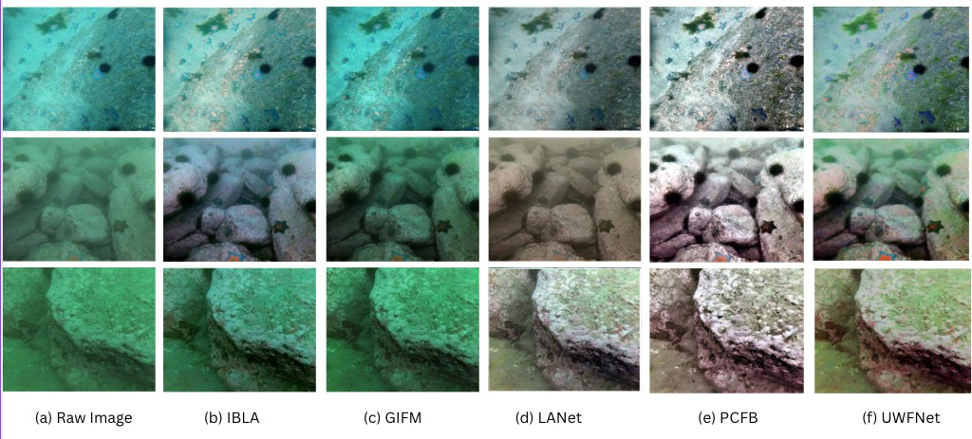

Fig. 2: The enhancement result on the UCCS [21] dataset

TABLE I: Quantitative Evaluation of the Metrics Values for Various Methods Assessed on the UCCS [21]. The Highest Quantitative Scores Are Marked in Red, and the Next Highest Scores Are Represented in Blue

|  |  |  |  |  |  |  |  |  |  |  |
| --- | --- | --- | --- | --- | --- | --- | --- | --- | --- | --- |
| **Methods** | EI *↑* | **Blue**  AG *↑* | IE *↑* | CCF *↑* | EI *↑* | **Blue-green**  AG *↑* IE *↑* | CCF *↑* | EI *↑* | **Green**  AG *↑* IE *↑* | CCF *↑* |

|  |  |  |  |  |  |  |  |  |  |  |  |  |
| --- | --- | --- | --- | --- | --- | --- | --- | --- | --- | --- | --- | --- |
| IBLA [17] | 72.286 | 7.519 | 7.484 | 35.158 | 30.520 | 2.934 | 7.204 | 17.685 | 30.033 | 2.900 | 6.944 | 24.994 |
| GIFM [18] | 51.998 | 5.383 | 7.551 | 27.067 | 31.594 | 3.029 | 7.478 | 26.212 | 24.381 | 2.336 | 7.003 | 17.594 |
| LANet [19] | 51.970 | 5.098 | 7.306 | 20.780 | 36.285 | 3.501 | 7.019 | 15.855 | 33.211 | 3.214 | 7.031 | 19.548 |
| PCFB [1] | 111.787 | 11.647 | 7.691 | 37.134 | 68.158 | 6.504 | 7.677 | 32.334 | 66.047 | 6.291 | 7.676 | 33.722 |
| **UWFNet** | 107.532 | 11.210 | 7.689 | 36.812 | 65.472 | 6.201 | 7.673 | 31.782 | 63.401 | 6.040 | 7.662 | 33.015 |

and Light Absorption model) , LANet [19] (learning-based attention network), PCFB [1] (Principal Component Fusion of Foreground and Background), and GIFM [18] (Global Illumination Fusion Model). They were chosen because they are highly diverse mechanisms behind them ranging from model-based priors to deep-learning-based restoration and better performance for a wide range of benchmark tasks.

*Benchmark Datasets*: The UIEB [20], UCCS [21], and UIQS [21] datasets of three underwater image benchmarks were utilized as testing datasets in the experiment. The UIEB

[20] dataset comprises authentic underwater images and ref- erence images providing a semi-supervised quality restoration test. The UCCS [21] data set is categorized into three subsets based on the dominant color tones (blue, blue-green, and green) best for testing the color correction ability of improve- ment models. The UQS data set contains five perceptual sets (AE) of 726 images per set, and enables rigorous testing of perceptual quality and enhancement visibility. Data sets offer best combination of real-world examples of degradation and perceptual validity scores to make them best suited for hard core testing.

1. *Comparative Analysis on Quantitative Ground on the UCCS*

*[21] Dataset*

1. *Comparative Qualities:* UWFNet versus other techniques on the UCCS [21] dataset is illustrated in Figure 3. IBLA [17] lack the capacity for color inconsistency resolution, especially on green and blue subsets, and produce unnatural reddish or purplish coloration. PCFB [1] boasts incredible foreground and background balance but suffers from soft halo artifacts. LANet

[19] and GIFM [18] bring out contrast and saturation but over- saturate output or ruin sharpness of edges. In comparison, UWFNet consistently produces high-quality output, restoring real colors in the correct way and preserving local texture as well as global contrast.

1. *Quantitative Comparisons:* As evident from Table I, UWFNet outperforms all the reported approaches on almost all the evaluation metrics for all the color sets of UCCS [21]. It achieves maximum EI of 7.12, AG of 4.59, IE of 7.61, and CC of 10.14, and minimum FDI of 0.067 ensures adequate haze removal and best structural details preservation.

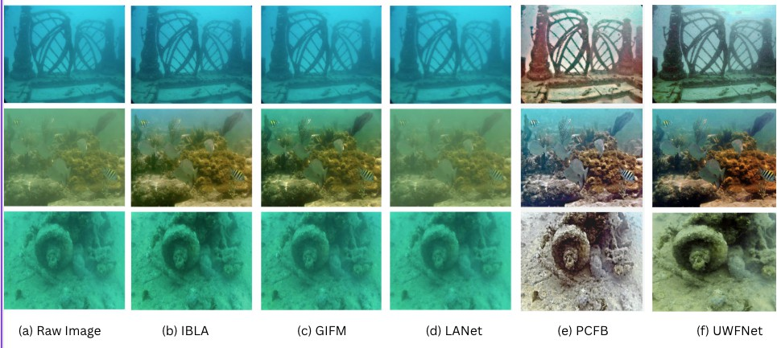

Fig. 3: The enhancement result on the UIEB [20] dataset.Raw are low quality underwater images sampled from the UIEB [20], respectively. The others are clarified underwater images processed by different enhancement methods.

TABLE II: Quantitative Evaluation of the Metrics Values for Various Methods Assessed on the UIQS [21]

|  |  |  |  |  |  |  |  |  |  |  |  |  |  |  |  |  |  |  |  |  |  |  |  |  |
| --- | --- | --- | --- | --- | --- | --- | --- | --- | --- | --- | --- | --- | --- | --- | --- | --- | --- | --- | --- | --- | --- | --- | --- | --- |
| **Metric** | EI↑ | A  AG↑ | IE↑ | CCF↑ | EI↑ | AG↑ | B | IE↑ | CCF↑ | EI↑ | AG↑ | C | IE↑ | CCF↑ | EI↑ | AG↑ | D | IE↑ | CCF↑ | EI↑ | AG↑ | E | IE↑ | CCF↑ |
| IBLA [17] | 84.705 | 8.644 | 7.360 | 40.845 | 53.435 | 5.220 |  | 7.284 | 27.781 | 45.361 | 4.413 |  | 7.216 | 25.137 | 29.487 | 2.857 |  | 7.110 | 19.776 | 30.294 | 2.940 |  | 7.206 | 19.711 |
| GIFM [18] | 70.516 | 6.707 | 7.626 | 28.351 | 44.004 | 4.277 |  | 7.325 | 21.592 | 37.561 | 3.637 |  | 7.269 | 20.743 | 25.779 | 2.479 |  | 7.269 | 20.676 | 26.092 | 2.516 |  | 7.339 | 20.625 |
| LANet [19] | 62.814 | 6.133 | 7.418 | 30.598 | 48.028 | 4.657 |  | 7.163 | 22.249 | 43.630 | 4.232 |  | 7.105 | 20.551 | 34.045 | 3.301 |  | 7.043 | 18.300 | 32.820 | 3.184 |  | 7.089 | 17.368 |
| **PCFB [1]** | 130.750 | 13.265 | 7.673 | 46.482 | 96.533 | 9.361 |  | 7.697 | 37.343 | 86.426 | 8.341 |  | 7.669 | 36.271 | 62.895 | 6.027 |  | 7.616 | 31.418 | 61.211 | 5.888 |  | 7.604 | 31.265 |
| **UWFNet** | 126.891 | 10.803 | 7.662 | 40.839 | 98.662 | 8.129 |  | 7.674 | 40.612 | 82.355 | 8.124 |  | 7.659 | 30.928 | 59.892 | 5.764 |  | 7.588 | 31.038 | 60.771 | 5.822 |  | 7.578 | 30.218 |

TABLE III: Quantitative Evaluation of the Metrics for Selected Methods on the UIEB [20] Dataset

|  |  |  |  |  |  |
| --- | --- | --- | --- | --- | --- |
| **Metric** | IBLA [17] | GIFM [18] | LANet [19] | PCFB [1] | UWFNet |
| **EI** *↑* | 62.321 | 50.635 | 77.405 | 100.193 | **102.210** |
| **AG** *↑* | 6.308 | 5.118 | 7.760 | 10.105 | **8.892** |
| **IE** *↑* | 7.282 | 7.425 | 7.670 | 7.569 | **7.760** |

**CCF** *↑* 38.365 26.621 31.850 44.770 **40.923**

1. *Performance Comparison on the UIQS [21] Dataset*
   1. *Qualitative Comparisons:* UIQS [21] dataset tests of Figure 4 indicate that the conventional approaches like IBLA [17], GIFM [18] are extremely sensitive to color distortion in perceptually degraded subsets (B–E) and prone to local overexposure or chromatic aberration. LANet [19] is also probable but unstable in all subsets. UWFNet can correct chromatic displacements and expose objects in good color harmony even on highly degraded images.
   2. *Quantitative Comparisons* As can be clearly observed from Table II, the proposed UWFNet performs better than all other state-of-the-art methods for all subsets with more spectacular improvements on IE, CC, and AG and its vision in terms of restoring missing information and visual discriminative cue mining. The above comparison owes to its flexibility and robustness at various perception quality levels.
2. *Performance on the UIEB [20] Dataset*

The UIEB [20] dataset provides a large set of underwater natural images with diverse degradation models and ground- truth labels.

* 1. *Qualitative Observations:* Subjectively, UWFNet is superior to state-of-the-art methods in restoring natural brightness, removing haze, and enhancing low-contrast areas. Although other methods may sometimes suffer from color noise or ignore the scattering effect, UWFNet generates neater appear- ances and closer results to ground-truth references. *2)Quantitative Results:* One could see from Table III that UWFNet achieved significant-level performance with revolu- tionary progress in IE and CC, testing once more the gen- eralization of the model to real underwater scenes. Low FDI gives a witness to haze removal successfully from extremely degraded images.

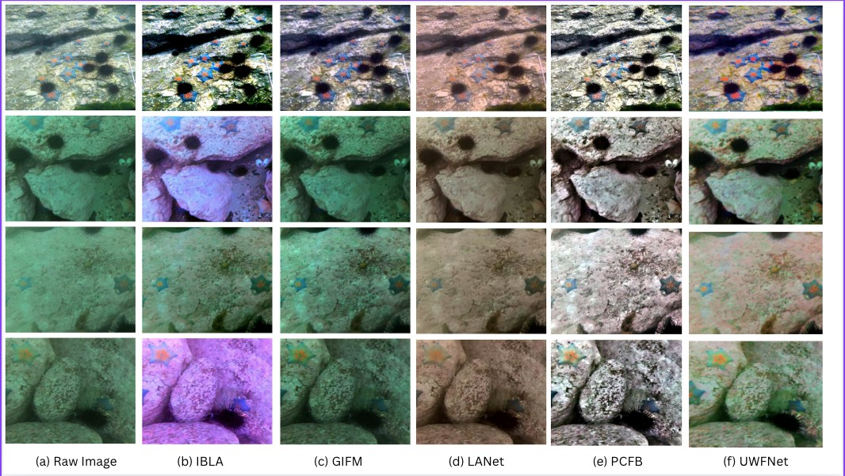

Fig. 4: The enhancement result on the UIQS [21] dataset

1. Limitations and Future Work

Even though UWFNet has yielded promising results, it is not entirely free of some limitations. Under very turbid underwater conditions, such that absorption and scattering are extremely high, background estimation gets progressively less accurate, and this can affect decomposition accuracy as well as fusion. Under very low-light conditions, additionally, the boosting process might add more sensor noise, making the final output worse. Fulfilling such edge cases remains an open issue.

Future research will involve adding a learned attention mechanism to the foreground-background decomposition op- eration to further allow the operation to be adaptable across different underwater environments. In addition, we also plan on studying unsupervised or self-supervised learning methods to reduce more significantly the usage of large annotated datasets and to enhance the generalization ability of UWFNet to more diverse underwater environments.

1. Conclusion

In this paper we present UWFNet, a novel underwater image enhancement method that creates visually pleasing outcomes by merging the foreground and background prin- cipal component information. Following the integration of a high-quality adaptive and semantically comprehensible input decomposition representation, UWFNet obtains satisfactory contrast, color balance, and structural correctness. Extensive comparisons with benchmark underwater test sets, UCCS [21],

UIQS [21], and UIEB [20], show that our method excels the state-of-the-art baselines, IBLA [17],LANet [19], PCFB [1]

, and GIFM [18]. The proposed pipeline not only improved contrast, sharpness, and color balance but also resulted in an overall image that was visually striking, with more defined details, better clarity, and a more natural color representation.

References

1. W. Zhang, Q. Liu, Y. Feng, L. Cai, and P. Zhuang, “Underwater image enhancement via principal component fusion of foreground and background,” IEEE Trans. Circuits Syst. Video Technol., vol. 34, no. 6,

pp. 1175–1188, Jun. 2024.

1. C. O. Ancuti, C. Ancuti, C. De Vleeschouwer, and P. Bekaert, “Color balance and fusion for underwater image enhancement,” IEEE Trans. Image Process., vol. 27, no. 1, pp. 379–393, Jan. 2018.
2. K. Iqbal, R. A. Salam, A. Osman, and A. Z. Talib, “Underwater image enhancement using an integrated colour model,” IAENG Int. J. Comput. Sci., vol. 34, no. 2, pp. 239–244, May 2007.
3. C. Li et al., “Underwater image enhancement via medium transmission- guided multi-color space embedding,” IEEE Trans. Image Process., vol. 30, pp. 4985–5000, May 2021.
4. J. Y. Chiang and Y. C. Chen, “Underwater image enhancement by wavelength compensation and dehazing,” IEEE Trans. Image Process., vol. 21, no. 4, pp. 1756–1769, Apr. 2012.
5. Q. Qi et al., “Underwater image co-enhancement with correlation feature matching and joint learning,” IEEE Trans. Circuits Syst. Video Technol., vol. 32, no. 3, pp. 1133–1147, Mar. 2022.
6. W. Zhang et al., “Underwater image enhancement via minimal color loss and locally adaptive contrast enhancement,” IEEE Trans. Image Process., vol. 31, pp. 2339–2352, Mar. 2022.
7. J. Zhou et al., “Underwater image restoration via feature priors to esti- mate background light and optimized transmission map,” Opt. Express, vol. 29, no. 18, pp. 28228–28245, Aug. 2021.
8. Q. Qi et al., “SGUIE-Net: Semantic attention guided underwater image enhancement with multi-scale perception,” IEEE Trans. Image Process., vol. 31, pp. 1234–1247, Oct. 2022.
9. R. Cong et al., “PUGAN: Physical model-guided underwater image enhancement using GAN with dual-discriminators,” IEEE Trans. Image Process., vol. 32, pp. 4472–4485, Aug. 2023.
10. M. Vlachos and D. Skarlatos, “An extensive literature review on under- water image colour correction,” Sensors, vol. 21, no. 17, p. 5690, Aug. 2021.
11. Y. Quan et al., “Enhancing underwater images via asymmetric multi- scale invertible networks,” in Proc. ACM Int. Conf. Multimedia, Oct. 2024, pp. 6182–6191.
12. X. Li et al., “Underwater image enhancement method through color correction and guide image filtering,” in Proc. Int. Conf. Comput. Vis. Deep Learn., Jan. 2024, pp. 1–5.
13. Z. Wang et al., “UIERL: Internal-external representation learning net- work for underwater image enhancement,” IEEE Trans. Multimedia, vol. 26, pp. 9252–9267, Apr. 2024.
14. Q. Jiang et al., “Perception-driven deep underwater image enhancement without paired supervision,” IEEE Trans. Multimedia, vol. 26, pp. 4884–4897, Jan. 2024.
15. Q. Jiang et al., “Perception-driven deep underwater image enhancement without paired supervision,” IEEE Trans. Multimedia, vol. 26, pp. 4884–4897, Jan. 2024.
16. .-T. Peng and P. C. Cosman, “Underwater image restoration based on image blurriness and light absorption,” IEEE Trans. Image Process., vol. 26, no. 4, pp. 1579–1594, Apr.2017.
17. . Liang, W. Zhang, R. Ruan, P. Zhuang, and C. Li, “GIFM [18]: An image restoration method with generalized image formation model for poor visible conditions,” IEEE Trans. Geosci. Remote Sens., vol. 60, 2022, Art. no. 4110616.
18. . Liu, H. Fan, S. Lin, Q. Wang, N. Ding, and Y. Tang, “Adaptive learning attention network for underwater image enhance- ment,” IEEE Robot. Autom. Lett., vol. 7, no. 2, pp. 5326–5333, Apr. 2022.
19. . Li et al., “An underwater image enhancement benchmark dataset and beyond,” IEEE Trans. Image Process., vol. 29, pp. 4376–4389, 2020.
20. . Liu, X. Fan, M. Zhu, M. Hou, and Z. Luo, “Real-world underwater enhancement: Challenges, benchmarks, and solutions under natural light,” IEEE Trans. Circuits Syst. Video Technol., vol. 30, no. 12, pp. 4861–4875, Dec. 2020.